Conceptual model

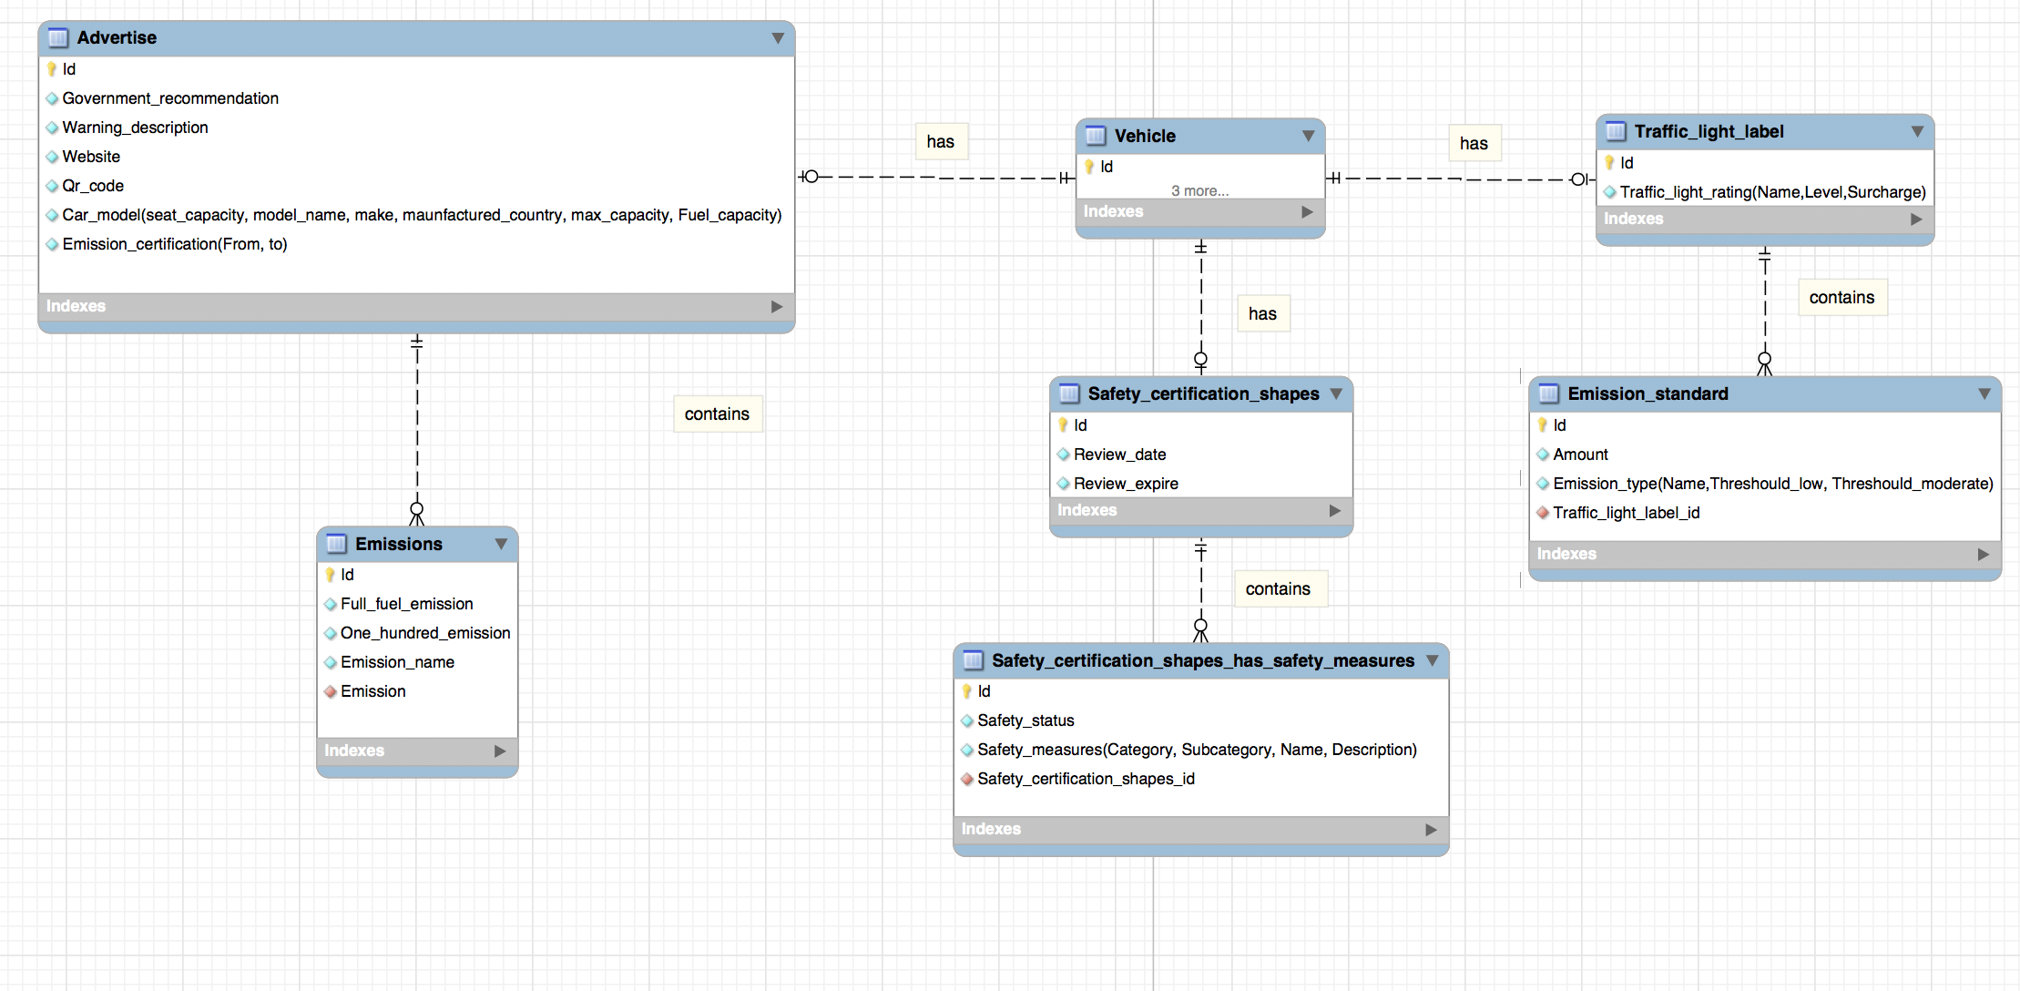

Physical model

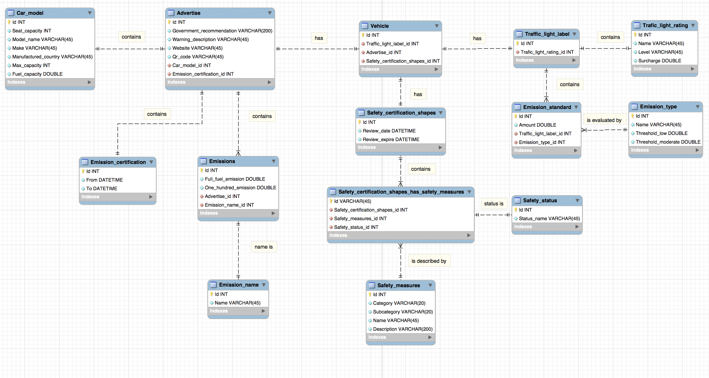

Assignment 1 Description

* As can be seen there is a table called “Safety_status”, which stores the safety measure status such as FAILS or SUCCESS. The reason why I put the status in a separate table rather than simply storing in the “Safety_certification_shapes_has_safety_measures” table is that INT type data costs less storage space than CHAR [45]. It is not obvious in the small amount of data, however, whenever there are 100 million data, the space cost difference is huge. The table “Emission_name” and “Trafic_light_rating” exist in similar reason.
* From the assignment specification, we know there are more than 20 safety measures that we should consider. To simplify this, “Safety_measures” table is used to store all measures, and the connection between this and “Safety_certification_shapes” table should be “many to many”. Therefore, an intermediate “Safety_certification_shapes_has_safety_measures” table is created to solve “many to many” problem. The “Emission_standard” table also acts as an intermediate between “Traffic_light_label” and “Emission_type”.
* I assumed that the QR code can be stored as string in “Advertise” table.
* There are some descriptions that should be put in “Advertise” table such as maximum capacity of the vehicle, but it is put in “Car_model” table. Because a car model may have more than one advertising, storing in the same table may generate duplicate data thus increase the cost of storage space.
* I assumed government recommendation is different in each advertising, therefore I didn’t create a separate table to store recommendations. However, if there are lots of the same recommendations, using a separate table is needed to save space.